In popup write only 2 admission Category
- Day Scholar
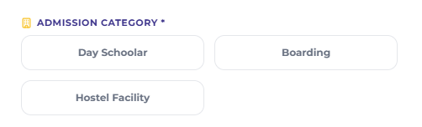
- Boarding/Hostel Facility


Remove this

Remove Leadership Committee word write management committee
Change heading write Meet Our Academic Excellence Team

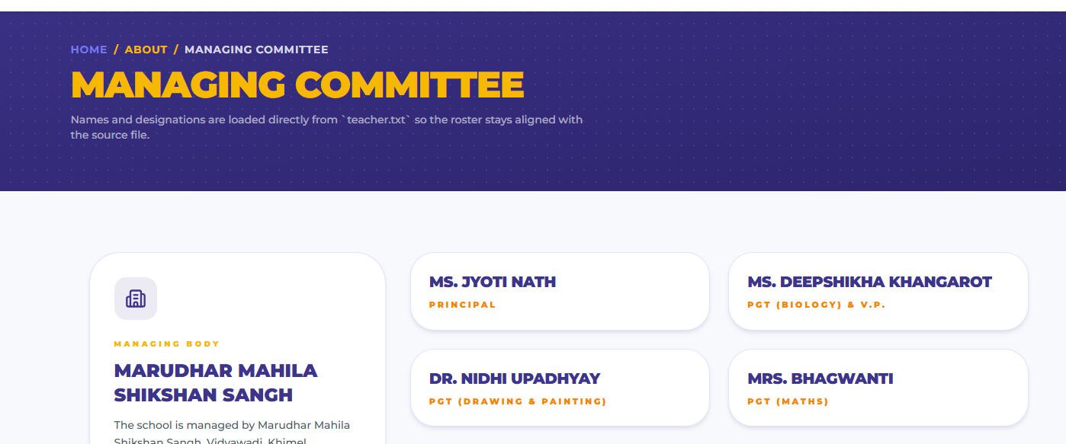
- In Acedemic Section Write Admission Guideline instead of eligibility creteria
- Take Fee Structure from official website of vidyawadi

About LPS Section Content

Best CBSE Girls' Boarding School in Rajasthan | Leeladevi Parasmal Sancheti English Medium Sr. Sec. School
Empowering Girls with Quality Education, Strong Values & Future-Ready Skills
Leeladevi Parasmal Sancheti English Medium Sr. Sec. School, a premier institution under Marudhar Mahila Shikshan Sangh (Vidyawadi), has been nurturing confident, compassionate, and successful young women through quality education and value-based learning.
Located on a beautiful, secure, and eco-friendly campus in Rani, Pali, Rajasthan, our school provides an ideal environment where girls are encouraged to explore their talents, excel academically, develop leadership skills, and become responsible global citizens.
As one of the leading CBSE girls' boarding schools in Rajasthan, we combine academic excellence with character development, innovation, sports, life skills, and cultural values to prepare every student for success in higher education and beyond.
Whether your daughter is beginning her educational journey in LKG or preparing for senior secondary education, we provide personalized learning experiences that inspire confidence, creativity, and lifelong learning.

Why Parents Choose Us
Choosing the right school shapes your child's future. At Leeladevi Parasmal Sancheti English Medium Sr. Sec. School, we offer a complete educational experience that supports academic achievement, emotional well-being, and holistic development.
Our Key Highlights
- CBSE Curriculum from LKG to Class XII
- Safe & Secure Residential Campus for Girls
- Comfortable Hostel with 24×7 Care
- Experienced & Qualified Faculty
- Smart Classrooms & Digital Learning
- Science, Mathematics & Computer Laboratories
- Well-Equipped Library
- Individual Attention & Mentorship
- Leadership & Personality Development Programs
- Sports, Yoga, Physical Fitness & Outdoor Activities
- Music, Dance, Arts & Cultural Education
- Skill Development & Life Skills Training
- Value-Based Education Rooted in Indian Culture
- Hygienic Dining Hall with Nutritious Meals
- Medical Care & Student Wellness Support
- Safe Transportation Facilities
- Green Campus Promoting Healthy Learning

Academic Excellence with Holistic Development
Education is not limited to textbooks. We believe every child possesses unique talents waiting to be discovered.
Our academic approach focuses on:
- Concept-based learning
- Critical thinking and problem-solving
- Creativity and innovation
- Communication and collaboration
- Digital literacy
- Leadership and entrepreneurship
- Scientific temperament
- Environmental awareness
- Social responsibility
Our experienced teachers create engaging classrooms where students become confident learners rather than passive recipients of knowledge.

A Home Away From Home
Parents trust us because we provide a nurturing residential environment where students feel safe, happy, and motivated.
Our hostel facilities include:
- Secure residential accommodation
- Caring hostel wardens
- Round-the-clock supervision
- Healthy and hygienic meals
- Medical support and infirmary
- Study hours with academic guidance
- Recreational facilities
- Clean and comfortable living spaces
Every child enjoys an atmosphere that feels truly like a second home.

Our Mission
Our mission is to provide a healthy, inclusive, and inspiring learning environment where every girl receives quality education, develops strong values, and gains the confidence to lead a meaningful life.
We strive to:
- Deliver excellence in CBSE education.
- Foster academic success and intellectual curiosity.
- Build confidence, discipline, and integrity.
- Encourage creativity, innovation, and critical thinking.
- Develop leadership and communication skills.
- Promote physical, emotional, and mental well-being.
- Inspire compassion, empathy, and social responsibility.
- Prepare students for lifelong learning and global opportunities.

Our Vision
To become one of India's most respected girls' educational institutions by nurturing confident, ethical, innovative, and socially responsible young women who positively transform society through knowledge, leadership, and compassion.

Our Aims & Objectives
We are committed to creating an educational environment where every student can achieve her highest potential.
Our objectives include:
- Providing equal learning opportunities for every child.
- Encouraging curiosity, creativity, and innovation.
- Building confidence, resilience, and self-esteem.
- Developing leadership qualities and teamwork.
- Promoting scientific inquiry and lifelong learning.
- Strengthening communication and interpersonal skills.
- Encouraging participation in sports, arts, and cultural activities.
- Preserving Indian values while embracing global perspectives.
- Teaching environmental responsibility and sustainable living.
- Preparing students for higher education and successful careers.
- Inspiring respect, kindness, integrity, and responsible citizenship.

Beyond Academics
At Leeladevi Parasmal Sancheti English Medium Sr. Sec. School, learning extends far beyond the classroom.
Students participate in:
- Sports & Athletics
- Yoga & Meditation
- NCC & Leadership Activities
- STEM Learning
- Science Exhibitions
- Robotics & Technology Exposure
- Debate & Public Speaking
- Performing Arts
- Music & Dance
- Creative Arts
- Cultural Celebrations
- Educational Tours
- Community Service Programs
These experiences help students become confident, independent, and future-ready.

Building Tomorrow's Women Leaders
Our purpose is simple—to educate, empower, and inspire every girl to become a confident leader, compassionate individual, and responsible citizen.
With academic excellence, modern infrastructure, experienced educators, strong moral values, and a secure residential campus, Leeladevi Parasmal Sancheti English Medium Sr. Sec. School continues to shape generations of young women ready to succeed in an ever-changing world.
Admissions Open
Join a learning community where education goes beyond classrooms, values shape character, leadership builds confidence, and every girl is empowered to achieve her dreams.

